**Hello World RESTful Web Service**

**HelloController.java:**

package com.cognizant.spring_learn.controller;

import org.slf4j.Logger;

import org.slf4j.LoggerFactory;

import org.springframework.web.bind.annotation.GetMapping;

import org.springframework.web.bind.annotation.RequestMapping;

import org.springframework.web.bind.annotation.RestController;

import com.cognizant.spring_learn.Country;

@RestController

@RequestMapping("")

public class HelloController {

private static final Logger LOGGER = LoggerFactory.getLogger(HelloController.class);

@GetMapping("/hello")

public String sayHello() {

LOGGER.info("START");

LOGGER.info("END");

return "Hello World";

}

}

**Logs:**



250709|12:23:14.661|http-nio-8080-exec-1| INFO|c.c.s.c.HelloController | sayHello|START

250709|12:23:14.661|http-nio-8080-exec-1| INFO|c.c.s.c.HelloController | sayHello|END

**Output:**

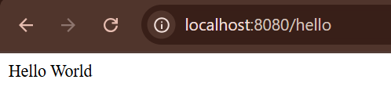

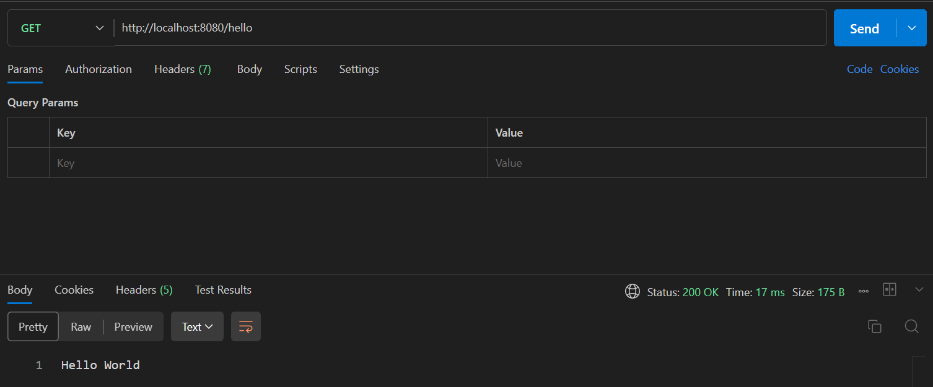

**REST - Country Web Service**

**CountryController.java:**

package com.cognizant.spring_learn.controller;

import org.springframework.web.bind.annotation.GetMapping;

import org.springframework.web.bind.annotation.RequestMapping;

import org.springframework.web.bind.annotation.RestController;

import com.cognizant.spring_learn.Country;

import com.cognizant.spring_learn.service.CountryService;

import org.slf4j.Logger;

import org.slf4j.LoggerFactory;

import org.springframework.context.ApplicationContext;

import org.springframework.context.support.ClassPathXmlApplicationContext;

import org.springframework.http.ResponseEntity;

*@RestController*

*@RequestMapping*("")

public class CountryController {

private static final Logger ***LOGGER*** = LoggerFactory.*getLogger*(CountryController.class);

ApplicationContext context=new ClassPathXmlApplicationContext("country.xml");

*@GetMapping*("/country")

public ResponseEntity<Country> getCountryIndia() {

***LOGGER***.info("START");

Country country=(Country)context.getBean("country");

***LOGGER***.info("END");

return ResponseEntity.*ok*(country);

}

}

**Logs:**

250709|12:32:38.084|http-nio-8080-exec-2| INFO|c.c.s.c.CountryController| getCountryIndia|START

250709|12:32:38.084|http-nio-8080-exec-2|DEBUG|c.c.spring_learn.Country | <init>|Inside Country Constructor.

250709|12:32:38.085|http-nio-8080-exec-2|DEBUG|c.c.spring_learn.Country | setCode|Setting country code to: IN

250709|12:32:38.085|http-nio-8080-exec-2|DEBUG|c.c.spring_learn.Country | setName|Setting country name to: India

250709|12:32:38.085|http-nio-8080-exec-2| INFO|c.c.s.c.CountryController| getCountryIndia|END

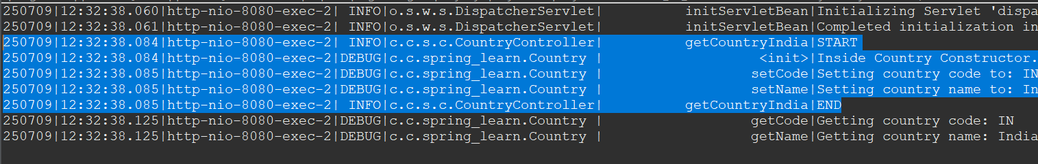

**Output:**

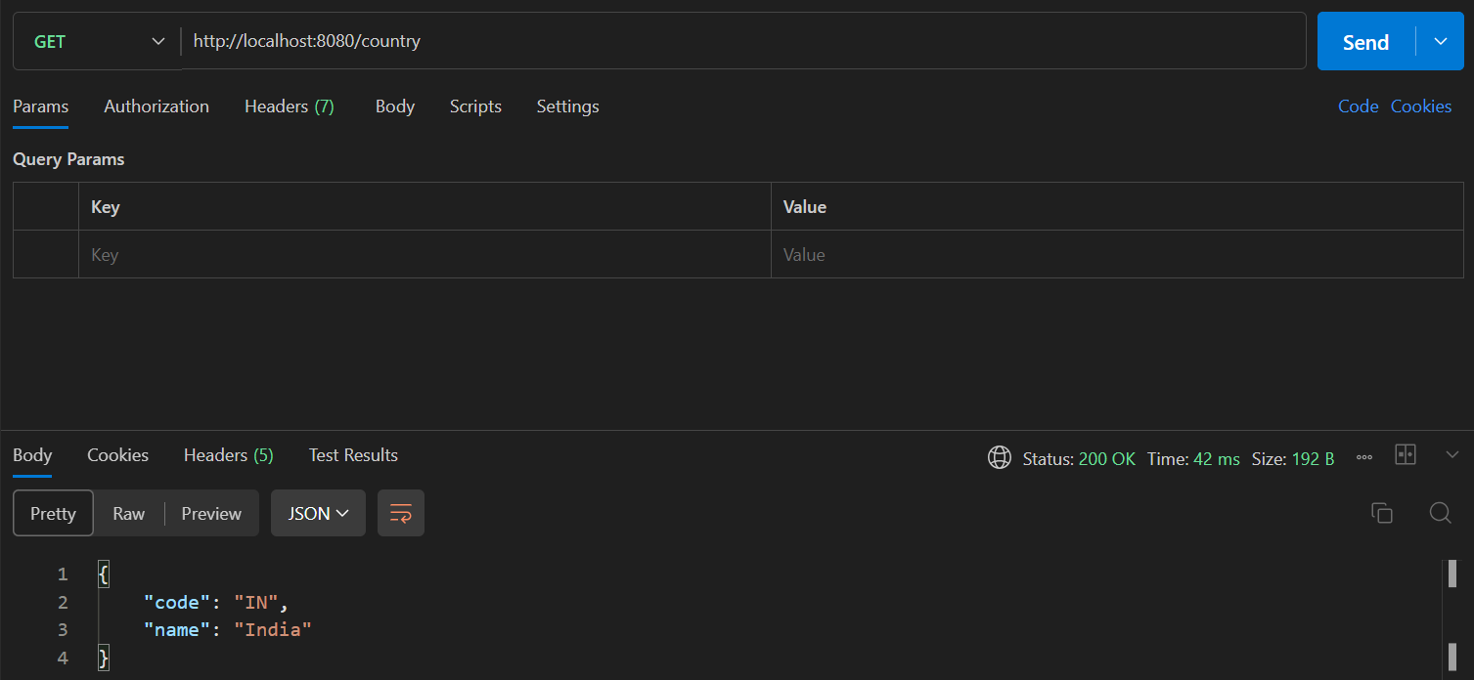

**REST - Get all countries**

**CountryController.java:**

package com.cognizant.spring_learn.controller;

import org.springframework.web.bind.annotation.GetMapping;

import org.springframework.web.bind.annotation.RequestMapping;

import org.springframework.web.bind.annotation.RestController;

import com.cognizant.spring_learn.Country;

import com.cognizant.spring_learn.service.CountryService;

import java.util.ArrayList;

import org.slf4j.Logger;

import org.slf4j.LoggerFactory;

import org.springframework.context.ApplicationContext;

import org.springframework.context.support.ClassPathXmlApplicationContext;

import org.springframework.http.ResponseEntity;

*@RestController*

*@RequestMapping*("")

public class CountryController {

private static final Logger ***LOGGER*** = LoggerFactory.*getLogger*(CountryController.class);

ApplicationContext context=new ClassPathXmlApplicationContext("country.xml");

*@GetMapping*("/countries")

public ResponseEntity<ArrayList<Country>> getAllCountries(){

***LOGGER***.info("START");

ArrayList<Country> countries=(ArrayList<Country>)context.getBean("countryList");

***LOGGER***.info("END");

return ResponseEntity.*ok*(countries);

}

}

**Logs:**

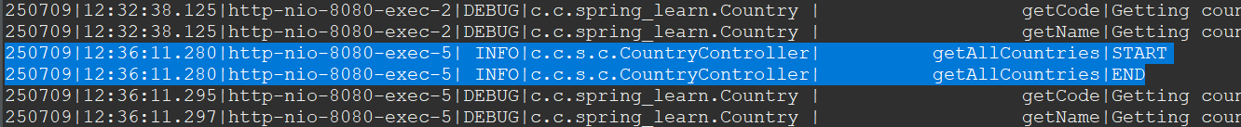

250709|12:36:11.280|http-nio-8080-exec-5| INFO|c.c.s.c.CountryController| getAllCountries|START

250709|12:36:11.280|http-nio-8080-exec-5| INFO|c.c.s.c.CountryController| getAllCountries|END

**Output:**

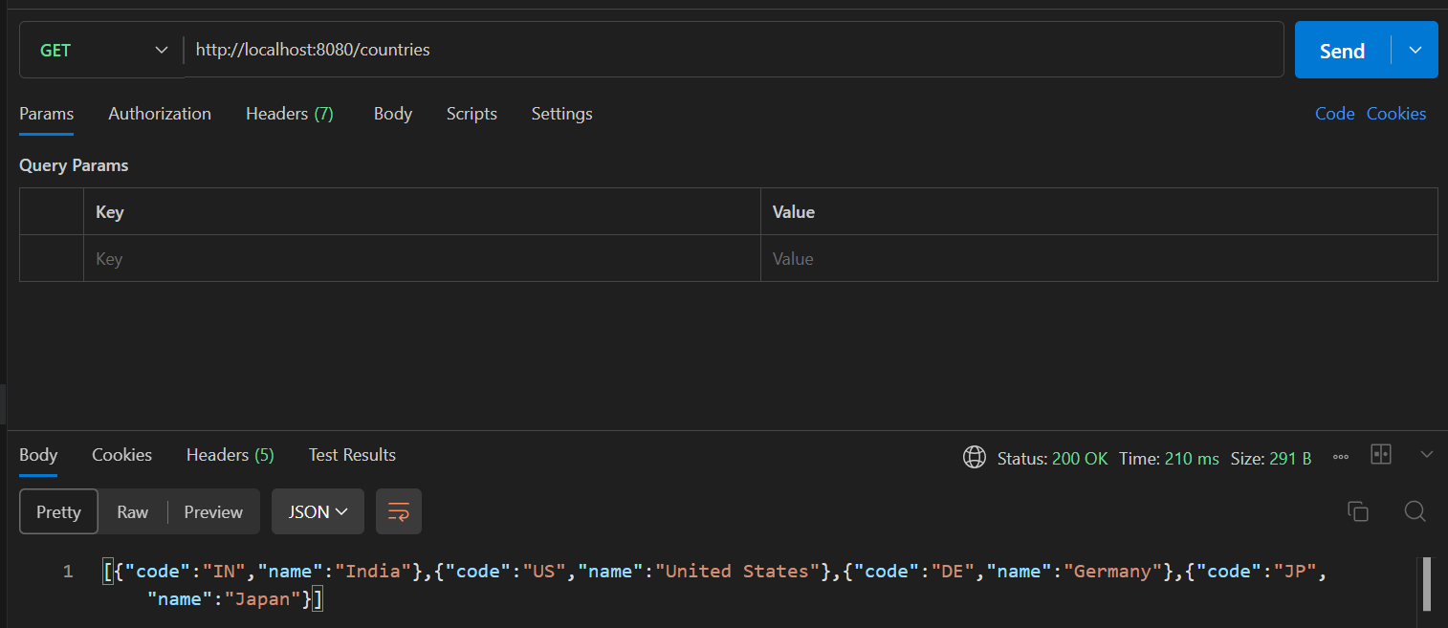

**REST - Get country based on country code**

**CountryController.java**

package com.cognizant.spring_learn.controller;

import org.springframework.web.bind.annotation.GetMapping;

import org.springframework.web.bind.annotation.PathVariable;

import org.springframework.web.bind.annotation.RequestMapping;

import org.springframework.web.bind.annotation.RestController;

import com.cognizant.spring_learn.Country;

import com.cognizant.spring_learn.service.CountryService;

import org.slf4j.Logger;

import org.slf4j.LoggerFactory;

import org.springframework.http.ResponseEntity;

*@RestController*

*@RequestMapping*("")

public class CountryController {

private static final Logger ***LOGGER*** = LoggerFactory.*getLogger*(CountryController.class);

*@Autowired*

CountryService countryService;

*@GetMapping*("/country/{code}")

public ResponseEntity<Country> getCountry(*@PathVariable* String code){

***LOGGER***.info("START");

Country country=countryService.getCountry(code);

***LOGGER***.info("END");

return ResponseEntity.*ok*(country);

}

}

**CountryService.java:**

package com.cognizant.spring_learn.service;

import java.util.ArrayList;

import org.slf4j.Logger;

import org.slf4j.LoggerFactory;

import org.springframework.context.ApplicationContext;

import org.springframework.context.support.ClassPathXmlApplicationContext;

import org.springframework.stereotype.Service;

import com.cognizant.spring_learn.Country;

*@Service*

public class CountryService {

private static final Logger ***LOGGER*** = LoggerFactory.*getLogger*(Country.class);

public Country getCountry(String code) {

ApplicationContext context=new ClassPathXmlApplicationContext("country.xml");

ArrayList<Country> countryList=(ArrayList<Country>)context.getBean("countryList");

***LOGGER***.info("Inside CountryService");

return countryList.stream().filter(c -> c.getCode().equalsIgnoreCase(code)).findFirst().orElse(null);

}

}

**Logs:**

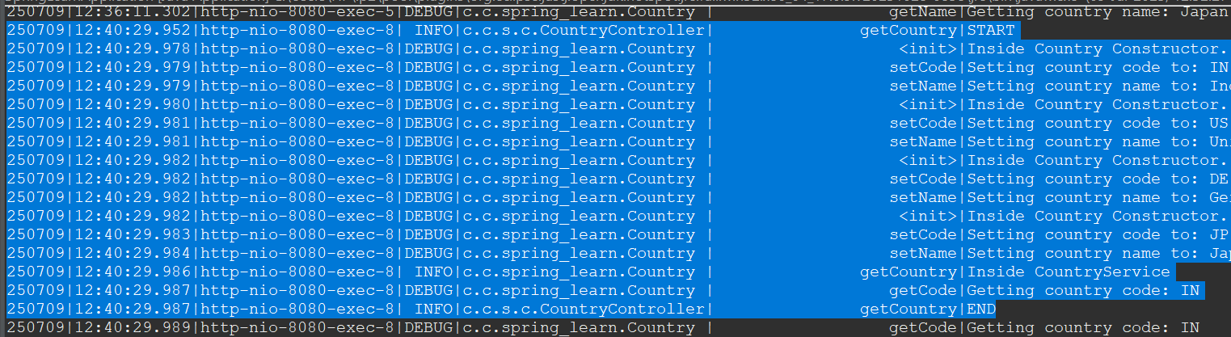

250709|12:40:29.952|http-nio-8080-exec-8| INFO|c.c.s.c.CountryController| getCountry|START

250709|12:40:29.978|http-nio-8080-exec-8|DEBUG|c.c.spring_learn.Country | <init>|Inside Country Constructor.

250709|12:40:29.979|http-nio-8080-exec-8|DEBUG|c.c.spring_learn.Country | setCode|Setting country code to: IN

250709|12:40:29.979|http-nio-8080-exec-8|DEBUG|c.c.spring_learn.Country | setName|Setting country name to: India

250709|12:40:29.980|http-nio-8080-exec-8|DEBUG|c.c.spring_learn.Country | <init>|Inside Country Constructor.

250709|12:40:29.981|http-nio-8080-exec-8|DEBUG|c.c.spring_learn.Country | setCode|Setting country code to: US

250709|12:40:29.981|http-nio-8080-exec-8|DEBUG|c.c.spring_learn.Country | setName|Setting country name to: United States

250709|12:40:29.982|http-nio-8080-exec-8|DEBUG|c.c.spring_learn.Country | <init>|Inside Country Constructor.

250709|12:40:29.982|http-nio-8080-exec-8|DEBUG|c.c.spring_learn.Country | setCode|Setting country code to: DE

250709|12:40:29.982|http-nio-8080-exec-8|DEBUG|c.c.spring_learn.Country | setName|Setting country name to: Germany

250709|12:40:29.982|http-nio-8080-exec-8|DEBUG|c.c.spring_learn.Country | <init>|Inside Country Constructor.

250709|12:40:29.983|http-nio-8080-exec-8|DEBUG|c.c.spring_learn.Country | setCode|Setting country code to: JP

250709|12:40:29.984|http-nio-8080-exec-8|DEBUG|c.c.spring_learn.Country | setName|Setting country name to: Japan

250709|12:40:29.986|http-nio-8080-exec-8| INFO|c.c.spring_learn.Country | getCountry|Inside CountryService

250709|12:40:29.987|http-nio-8080-exec-8|DEBUG|c.c.spring_learn.Country | getCode|Getting country code: IN

250709|12:40:29.987|http-nio-8080-exec-8| INFO|c.c.s.c.CountryController| getCountry|END

**Output:**

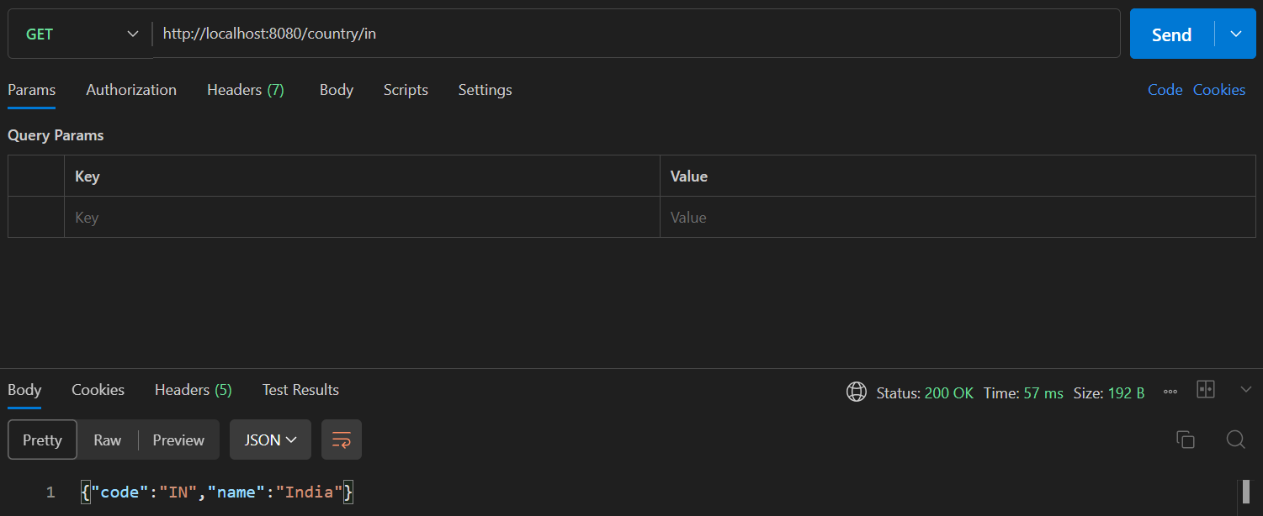

**REST - Get country exceptional scenario**

**CountryController.java:**

package com.cognizant.spring_learn.controller;

import org.springframework.web.bind.annotation.GetMapping;

import org.springframework.web.bind.annotation.PathVariable;

import org.springframework.web.bind.annotation.RequestMapping;

import org.springframework.web.bind.annotation.RestController;

import com.cognizant.spring_learn.Country;

import com.cognizant.spring_learn.service.CountryService;

import com.cognizant.spring_learn.service.exception.CountryNotFoundException;

import org.slf4j.Logger;

import org.slf4j.LoggerFactory;

import org.springframework.beans.factory.annotation.Autowired;

import org.springframework.http.ResponseEntity;

@RestController

@RequestMapping("")

public class CountryController {

private static final Logger LOGGER = LoggerFactory.getLogger(CountryController.class);

@Autowired

CountryService countryService;

@GetMapping("/country/{code}")

public ResponseEntity<Country> getCountry(@PathVariable String code){

LOGGER.info("START");

Country country=countryService.getCountry(code);

LOGGER.info("END");

return ResponseEntity.ok(country);

}

}

**CountryService.java:**

package com.cognizant.spring_learn.service;

import java.util.ArrayList;

import org.slf4j.Logger;

import org.slf4j.LoggerFactory;

import org.springframework.context.ApplicationContext;

import org.springframework.context.support.ClassPathXmlApplicationContext;

import org.springframework.stereotype.Service;

import com.cognizant.spring_learn.Country;

import com.cognizant.spring_learn.service.exception.CountryNotFoundException;

@Service

public class CountryService {

private static final Logger LOGGER = LoggerFactory.getLogger(Country.class);

public Country getCountry(String code){

ApplicationContext context=new ClassPathXmlApplicationContext("country.xml");

ArrayList<Country> countryList=(ArrayList<Country>)context.getBean("countryList");

LOGGER.info("Inside CountryService");

Country country=countryList.stream()

.filter(c -> c.getCode().equalsIgnoreCase(code))

.findFirst()

.orElseThrow(() -> new CountryNotFoundException("Country not found with code: " + code));

return country;

}

}

**CountrynotFoundException.java:**

package com.cognizant.spring_learn.service.exception;

import org.springframework.http.HttpStatus;

import org.springframework.web.bind.annotation.ResponseStatus;

@ResponseStatus(value=HttpStatus.NOT_FOUND,reason="Country not found")

public class CountryNotFoundException extends RuntimeException{

public CountryNotFoundException(String s) {

super(s);

}

}

**Logs:**

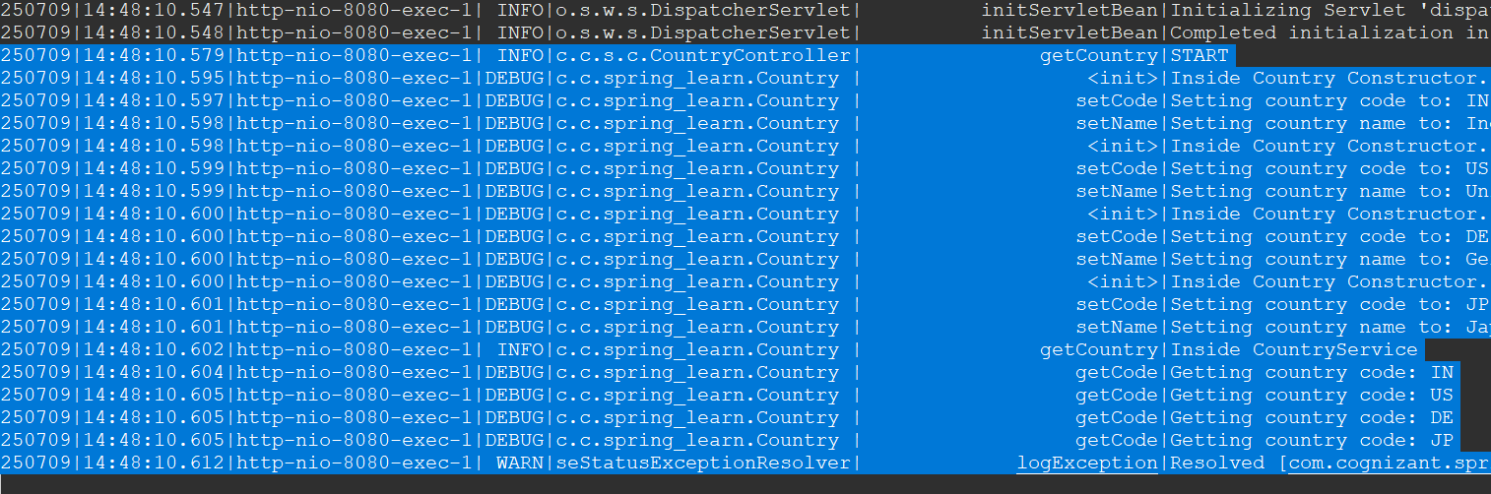

250709|14:48:10.579|http-nio-8080-exec-1| INFO|c.c.s.c.CountryController| getCountry|START

250709|14:48:10.595|http-nio-8080-exec-1|DEBUG|c.c.spring_learn.Country | <init>|Inside Country Constructor.

250709|14:48:10.597|http-nio-8080-exec-1|DEBUG|c.c.spring_learn.Country | setCode|Setting country code to: IN

250709|14:48:10.598|http-nio-8080-exec-1|DEBUG|c.c.spring_learn.Country | setName|Setting country name to: India

250709|14:48:10.598|http-nio-8080-exec-1|DEBUG|c.c.spring_learn.Country | <init>|Inside Country Constructor.

250709|14:48:10.599|http-nio-8080-exec-1|DEBUG|c.c.spring_learn.Country | setCode|Setting country code to: US

250709|14:48:10.599|http-nio-8080-exec-1|DEBUG|c.c.spring_learn.Country | setName|Setting country name to: United States

250709|14:48:10.600|http-nio-8080-exec-1|DEBUG|c.c.spring_learn.Country | <init>|Inside Country Constructor.

250709|14:48:10.600|http-nio-8080-exec-1|DEBUG|c.c.spring_learn.Country | setCode|Setting country code to: DE

250709|14:48:10.600|http-nio-8080-exec-1|DEBUG|c.c.spring_learn.Country | setName|Setting country name to: Germany

250709|14:48:10.600|http-nio-8080-exec-1|DEBUG|c.c.spring_learn.Country | <init>|Inside Country Constructor.

250709|14:48:10.601|http-nio-8080-exec-1|DEBUG|c.c.spring_learn.Country | setCode|Setting country code to: JP

250709|14:48:10.601|http-nio-8080-exec-1|DEBUG|c.c.spring_learn.Country | setName|Setting country name to: Japan

250709|14:48:10.602|http-nio-8080-exec-1| INFO|c.c.spring_learn.Country | getCountry|Inside CountryService

250709|14:48:10.604|http-nio-8080-exec-1|DEBUG|c.c.spring_learn.Country | getCode|Getting country code: IN

250709|14:48:10.605|http-nio-8080-exec-1|DEBUG|c.c.spring_learn.Country | getCode|Getting country code: US

250709|14:48:10.605|http-nio-8080-exec-1|DEBUG|c.c.spring_learn.Country | getCode|Getting country code: DE

250709|14:48:10.605|http-nio-8080-exec-1|DEBUG|c.c.spring_learn.Country | getCode|Getting country code: JP

250709|14:48:10.612|http-nio-8080-exec-1| WARN|seStatusExceptionResolver| logException|Resolved [com.cognizant.spring_learn.service.exception.CountryNotFoundException: Country not found with code: ino]

**Output:**

Correct Country Code:

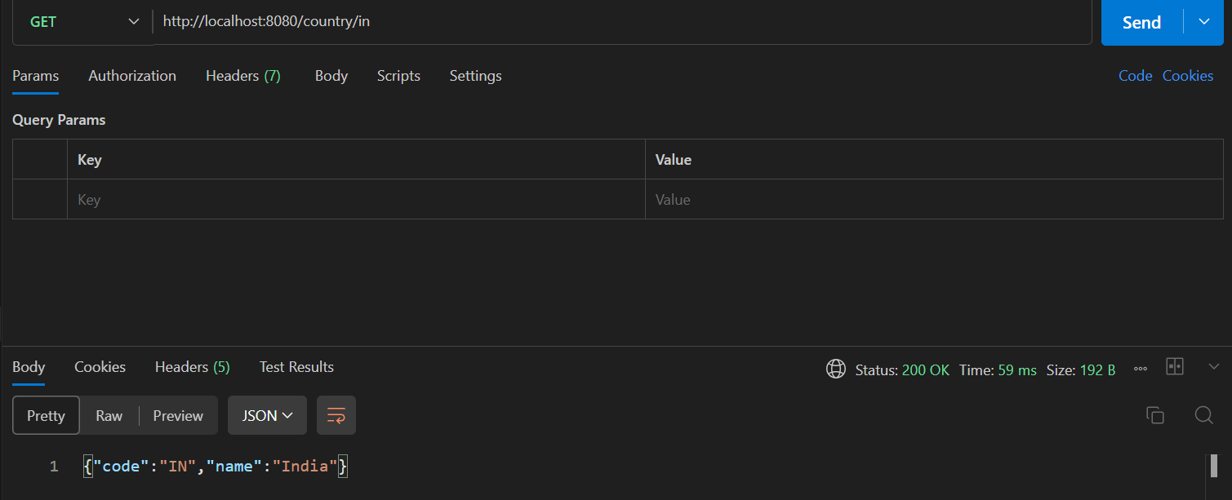

Wrong Country Code:

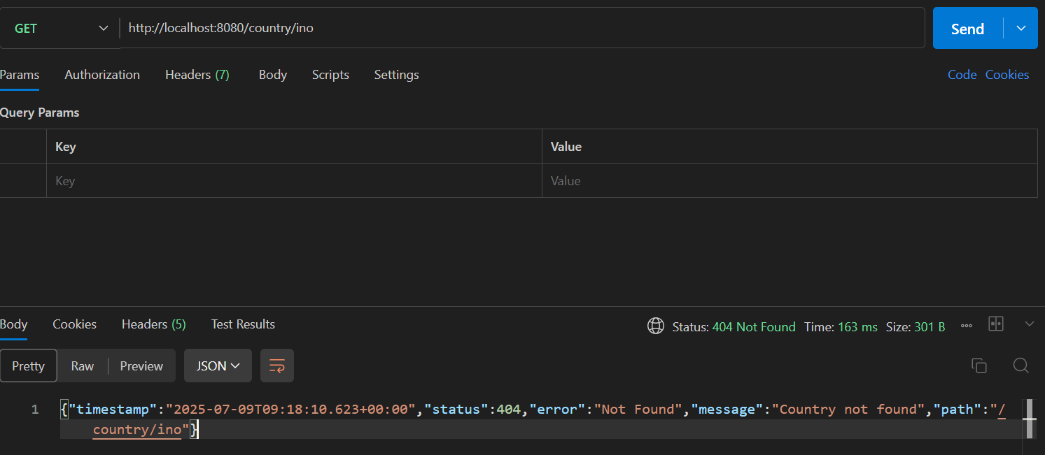

**MockMVC - Test get country service**

**contextLoads():**

*package com.cognizant.spring_learn;*

*import com.cognizant.spring_learn.controller.CountryController;*

*import static org.junit.jupiter.api.Assertions.assertNotNull;*

*import org.junit.jupiter.api.Test;*

*import org.springframework.beans.factory.annotation.Autowired;*

*import org.springframework.boot.test.context.SpringBootTest;*

*import org.springframework.test.web.servlet.ResultActions*

*@SpringBootTest*

*class SpringLearnApplicationTests {*

*@Autowired*

*private CountryController countryController;*

*@Test*

*public void contextLoads() {*

*assertNotNull(countryController);*

*}*

}

**Output:**

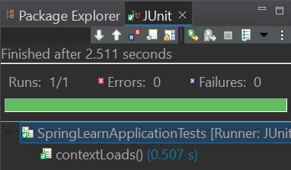

**Logs:**

 250709|15:02:01.984|main | INFO|c.c.s.c.CountryController| <init>|Country Controller Initialized

**testGetCountry():**

package com.cognizant.spring_learn;

import com.cognizant.spring_learn.controller.CountryController;

import static org.junit.jupiter.api.Assertions.*assertNotNull*;

import org.junit.jupiter.api.Test;

import org.springframework.beans.factory.annotation.Autowired;

import org.springframework.boot.test.autoconfigure.web.servlet.AutoConfigureMockMvc;

import org.springframework.boot.test.context.SpringBootTest;

import org.springframework.test.web.servlet.MockMvc;

import org.springframework.test.web.servlet.ResultActions;

import static org.springframework.test.web.servlet.request.MockMvcRequestBuilders.*get*;

import static org.springframework.test.web.servlet.result.MockMvcResultMatchers.*status*;

import static org.springframework.test.web.servlet.result.MockMvcResultMatchers.*jsonPath*;

*@AutoConfigureMockMvc*

*@SpringBootTest*

class SpringLearnApplicationTests {

*@Autowired*

private CountryController countryController;

*@Autowired*

private MockMvc mvc;

*@Test*

public void contextLoads() {

*assertNotNull*(countryController);

}

*@Test*

public void testGetCountry() throws Exception {

ResultActions actions = mvc.perform(*get*("/country"));

actions.andExpect(*status*().isOk());

actions.andExpect(*jsonPath*("$.code").exists());

actions.andExpect(*jsonPath*("$.code").value("IN"));

actions.andExpect(*jsonPath*("$.name").exists());

actions.andExpect(*jsonPath*("$.name").value("India"));

}

}

**Output:**

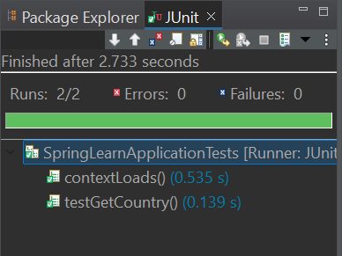

**MockMVC - Test get country service for exceptional scenario**

**testGetCountryException():**

package com.cognizant.spring_learn;

import com.cognizant.spring_learn.controller.CountryController;

import static org.junit.jupiter.api.Assertions.*assertNotNull*;

import org.junit.jupiter.api.Test;

import org.springframework.beans.factory.annotation.Autowired;

import org.springframework.boot.test.autoconfigure.web.servlet.AutoConfigureMockMvc;

import org.springframework.boot.test.context.SpringBootTest;

import org.springframework.test.web.servlet.MockMvc;

import org.springframework.test.web.servlet.ResultActions;

import static org.springframework.test.web.servlet.request.MockMvcRequestBuilders.*get*;

import static org.springframework.test.web.servlet.result.MockMvcResultMatchers.*status*;

import static org.springframework.test.web.servlet.result.MockMvcResultMatchers.*jsonPath*;

*@AutoConfigureMockMvc*

*@SpringBootTest*

class SpringLearnApplicationTests {

*@Autowired*

private CountryController countryController;

*@Autowired*

private MockMvc mvc;

*@Test*

public void contextLoads() {

*assertNotNull*(countryController);

}

*@Test*

public void testGetCountry() throws Exception {

ResultActions actions = mvc.perform(*get*("/country"));

actions.andExpect(*status*().isOk());

actions.andExpect(*jsonPath*("$.code").exists());

actions.andExpect(*jsonPath*("$.code").value("IN"));

actions.andExpect(*jsonPath*("$.name").exists());

actions.andExpect(*jsonPath*("$.name").value("India"));

}

*@Test*

public void testGetCountryException() throws Exception{

ResultActions actions = mvc.perform(*get*("/country/ino"));

actions.andExpect(*status*().isBadRequest());

actions.andExpect(*status*().reason("Country not found"));

}

}

**Output:**

